I Decided to Bow My Head at the Name of Jesus
By Br. Isidore Rice, O.P. January 3, 2019

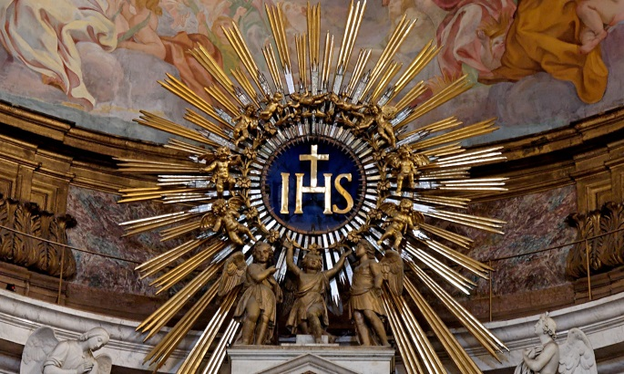
I decided to bow my head at the name of Jesus. I wish I could say I was led to this by feelings of pious devotion. I was not. I just saw some priests doing it and it seemed like a good idea; we call His name holy after all. So I decided to bow my head at the name of Jesus.
I wish I could say my motives were perfectly pure, but honestly, I hoped to be seen. When I bowed my head at the name of Jesus, certainly someone would take note, and they would think me quite pious and holy. Not everybody bows their head at the name of Jesus, you know. That’s not why I did it, at least not usually, but the thought was not displeasing to me. But I decided to bow my head at the name of Jesus.
The name of Jesus comes up a lot in Mass. At first, I usually missed my chance to bow my head. I had to start listening, to start noticing. After all, I had decided to bow my head at the name of Jesus. It always comes up twice in the Gloria, once in the Creed. After the Our Father, it comes at the end of the priest’s prayer and then he says it again right away after “the kingdom the power and the glory…” You can get on a roll at that part.
Depending on the Eucharistic Prayer, the number of opportunities varies. If I listened at the beginning, I could know which one it was and when to bow; I had decided to bow my head at the name of Jesus. It always comes up soon before the consecration. That is really neat; I’ll have to think more about that. I like it best when it comes up right before the doxology—“through Him with Him and in Him”—culminating it all.
The Collect and Preface are tricky. Sometimes you get the name of Jesus, sometimes just “Christ” or “Son.” Should I bow my head at “Christ”? If I do, it can’t hurt, but I had decided to bow my head at the name of Jesus. What about the readings and the homily? Some priests say the name of Jesus a lot when they preach (I hope I’ll be one of those). In the meantime, though, I could end up looking like a bobble head. What will people think? Does it matter? I have decided to bow my head at the name of Jesus.
The name Jesus means God saves. It’s hard to find a better summary of the Gospel than that. Scripture talks a lot about God’s name: I am who I am; the almighty has done great things for me and holy is His name; at the name of Jesus every knee shall bow; Hallowed be thy name. I like that. It directs us to what is most important, what is most wonderful, what is most true. When I hear that name now, I might even be touched with thoughts of pious devotion. I decided to bow my head at the name of Jesus.
✠

